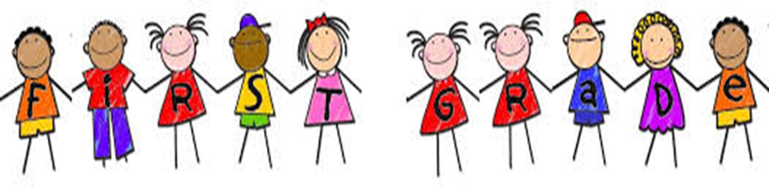

Schedule

|  |  |
| --- | --- |
| 8:50 - 9:10 | Arrival, Calendar & Class Meeting |
| 9:15 - 10:15 | Specials (P.E., Music, Art, Library) |
| 10:15 - 11:15 | Math Workshop |
| 11:15 - 12:10 | Writer’s Workshop |
| 12:10 - 12:45 | Recess & Lunch |
| 12:45 - 1:45 | Reader’s Workshop |
| 1:45 - 2:30 | Science & Social Studies |
| 2:30 - 2:45 | 1st Grade Earned Recess |
| 2:45 - 3:10 | Shared Reading |
| 3:10 - 3:45 | Word Work & Guided Reading |
| 3:45 - 3:55 | Clean Up, Pack Up & Stack Up |
| 3:55 - 4:05 | Dismissal |

2018 - 2019